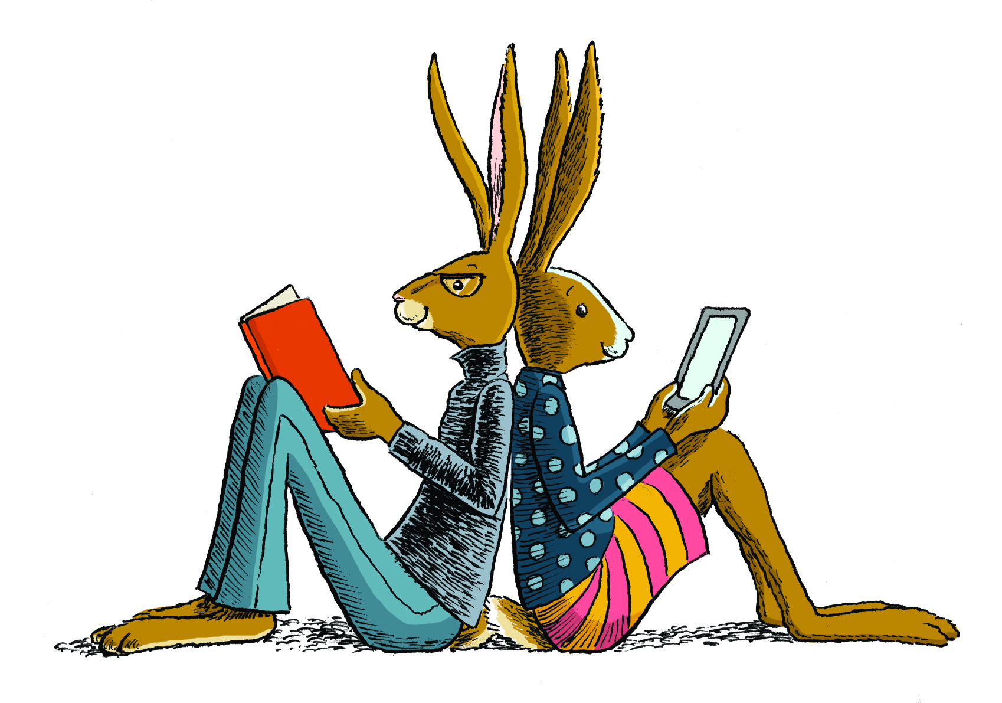Summer Reading: Students entering third, fourth, and fifth grade
Directions: Choose a book to read. The book can be fiction or nonfiction! Select a box to complete. Use the box as a guide when having a conversation about your book with an adult. Try to complete as many boxes as you can in one summer. Stick to one topic, or you can branch out. Be sure to keep track of the books you have read in the reading log, so you can share it with your teacher!
Who is the main character?  What happened in the book?  Where did the book take place?  Were there any problems in the story?  Be sure to use lots of details from the text when sharing your answers!!! | What was the lesson you learned from your book? Share the key details you learned!  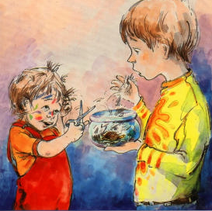 | Describe your favorite character out of all of the books you read this summer. What did they do in the story?  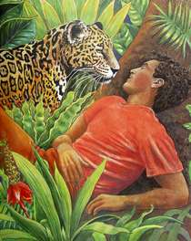
Make a list of new words you found while reading—put a check mark next to a word you found more than once—write down the meaning of words that received a check mark. You can ask an adult, consult a dictionary, or use a different tool to find the meaning of the words. | Read a fiction or nonfiction chapter book. Explain what chapter was your favorite and why. Be sure to share where the chapter fits into the text! | Give one of the characters in your story a voice. Write a journal from the point of view of one of your characters that shares the events in the story. Be sure to use first person.  First person: I just ate breakfast.  Third person: Amelia Bedelia just ate breakfast.
Watch an online video about a topic you read about.
Watch the video with a grownup and share with the grownup what new information you learned from watching the video about the topic of your book.
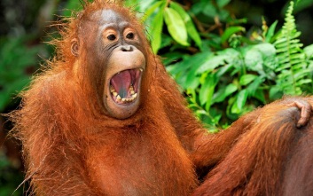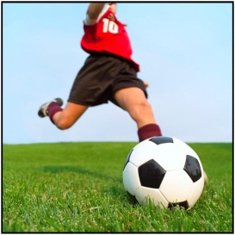
Here are some good videos about animals: http://video.nationalgeographic.com/video/kids/
Here are some good videos about sports and current events:http://www.timeforkids.com/photos-video
You can also check out the online databases available through our school library!

Reading Log: Books I have Read This Summer
Title:  Author:  One Sentence about Your Book: | Title:  Author:  One Sentence about Your Book:
Title:  Author:  One Sentence about Your Book: | Title:  Author:  One Sentence about Your Book:

Reading Log: Books I have Read This Summer
Title:  Author:  One Sentence about Your Book: | Title:  Author:  One Sentence about Your Book:
Title:  Author:  One Sentence about Your Book: | Title:  Author:  One Sentence about Your Book:

Reading Log: Books I have Read This Summer
Title:  Author:  One Sentence about Your Book: | Title:  Author:  One Sentence about Your Book:
Title:  Author:  One Sentence about Your Book: | Title:  Author:  One Sentence about Your Book:

